Huong Phan, Khoa Nguyen

Bioinformatics - Module 3 Capstone

**Abstract**

Magnesium has been shown to play a very important role in the bacterial growth. Various studies have found that differences in magnesium concentration had a significant impact on cellular division in bacteria by controlling the cell cycle (Walker, 1986). A deficiency of magnesium might lead to failure of cellular division at the final stage. A lower magnesium concentration was correlated with a decrease in amino acids assimilation, leading to a slower rate of synthesis of proteins that are essential for cellular growth (Webb, 1953). Additional studies also showed that magnesium and potassium may serve as cofactors for the activity pyruvate kinase, an important enzyme for glycolysis in several bacteria (De Médicis, 1986). Therefore, in our study, we hypothesized that magnesium concentration was positively correlated with cellular division activity and pyruvate kinase complex synthesis activity. We investigated the correlation of magnesium concentration with the amount of cellular division at level 1 function ontology level and cell cycle and correlation of magnesium concentration with pyruvate kinase complex expression at level 2 ontology level using 40 metagenomics samples from Earlham college in research in 2012 and 2013 on MG-RAST API. We also investigated whether there was a difference in results across samples from Corn or Soy fields, or between Till or No-till samples. Our results did not show a significant relationship for magnesium concentration and both cellular division activity and Pyruvate kinase associated cluster across all samples, Till samples, No-till samples, Corn samples and Soy samples. We concluded that our results did not agree with previous studies that cellular division and pyruvate kinase synthesis are dependent on magnesium concentration.

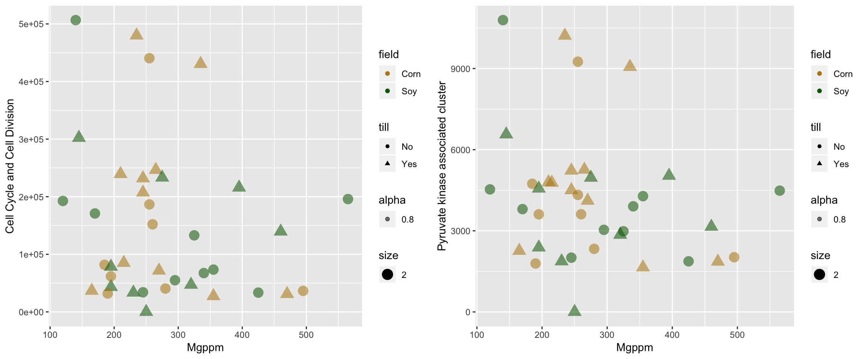**Figure 1.** Scatter plots of abundance of cell cycle and cell division functional group and pyruvate kinase associated cluster against magnesium concentration within corn and soy fields and within each type of treatment, and across all fields.

**References:**

De Médicis, Eveline. "Magnesium, manganese and mutual depletion systems in halophilic bacteria." *FEMS Microbiology Reviews* 2.1-2 (1986): 137-143.

Walker, Graeme M. "Magnesium and cell cycle control: an update." *Magnesium* 5.1 (1986): 9-23.

Webb, M. “Effects of Magnesium on Cellular Division in Bacteria.” *Science*, vol. 118, no. 3073, 1953, pp. 607–611.